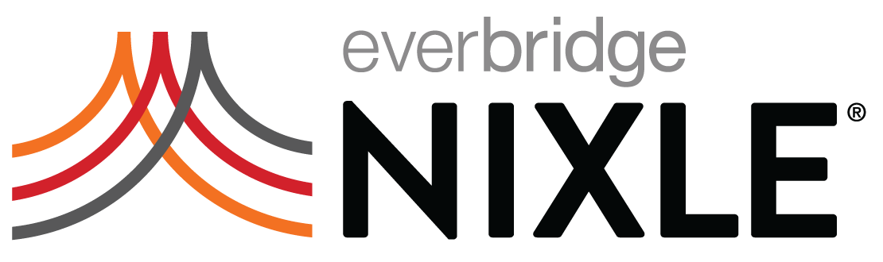
Use Nixle tag lines when you want to promote the system- but don’t have much room to do it! Great for utility bills, e-mail signatures, city newsletters and more!

Up-to-the-minute updates from city agencies by email and cell phone: www.nixle.com

Trusted neighborhood information- register for city updates at www.nixle.com

Important city advisories available 24 hours a day online at www.nixle.com

Alerts and community information online now at www.nixle.com

Official up-to-the-minute neighborhood information – register to receive by email and cell phone at www.nixle.com!

Construction and road closure updates by email and text message- go to www.nixle.com

(Insert Agency Name Here) & Nixle: partners in community information. Find out what’s happening in your neighborhood at www.nixle.com

Stay up-to-date on happenings in your neighborhood. Sign up for official emails from the city at www.nixle.com!

Email & text message updates about the areas you live, work, and visit. Go to www.nixle.com to register for official city information.

