How to change agency username in Nixle

Please be sure to be logged into the VPN

1. Log into agency.nixle.com/siteadmin
2. Select “Users” under authentication and authorization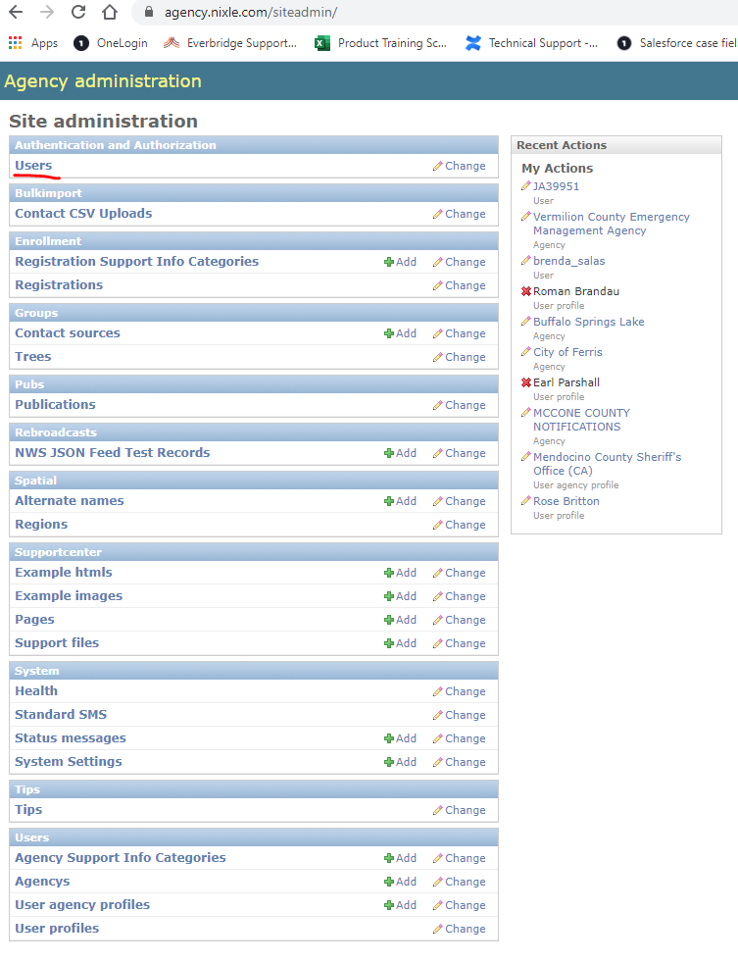
3. Search for the username you’d like to change 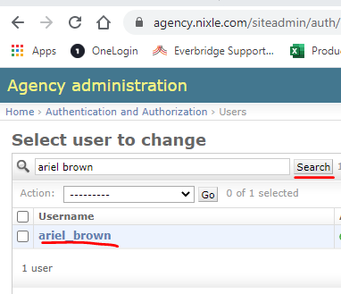
4. Change the username per client request, then click save 