[YOUR AGENCY NAME HERE] EMERGENCY ALERTING AND NOTIFICATION SYSTEM
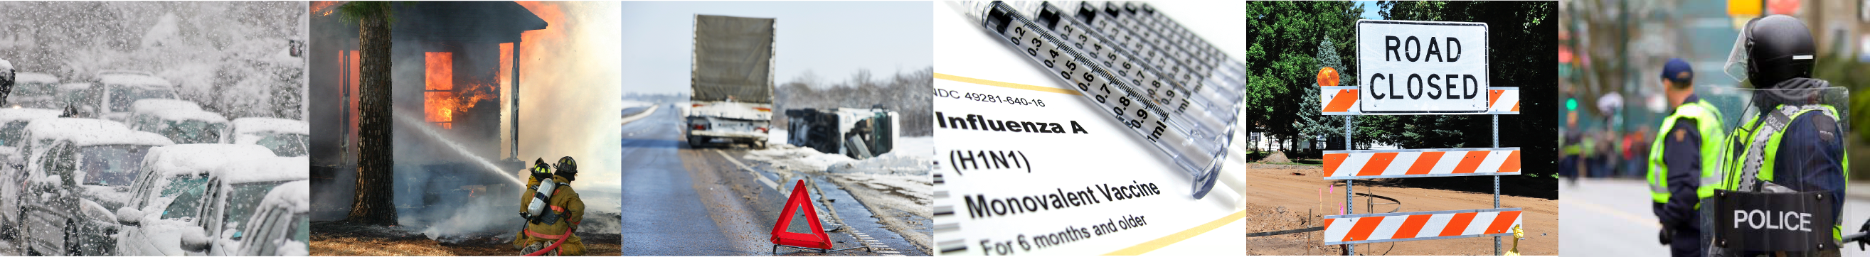

Dear Parents,

The [Your Agency Name Here] wants you and your children to be safe and informed during emergencies in our area, both during and after school. These may include public safety threats, dangerous weather, and traffic advisories. Information is key, and we strongly encourage you to sign up to receive text message alerts directly from [Your Agency Name Here].

Registering for alerts is easy — simply text your Zip Code to 888777 and you’ll be informed and instructed when necessary.
TEXT YOUR ZIP CODE TO 888777
TO SIGN UP FOR ALERTS

